**Our Energy Future**

**Future of Nuclear Energy**

Nuclear fission is a process in which a *fissile* nucleus like Uranium235 is bombarded with a neutron, causing the fissile nucleus to split into two. This not only creates energy but also release a couple neutrons which can strike a different fissile nucleus thus repeating the process.

The challenge is to engineer the core of the reactor so that we have a net “steady state”. This means that for every incoming neutron that’s absorved in the fissile nucleus, it spawns another neutron which is available to be absorbed in the next generation of fission, with the excess neutrons being lost through diffusion or absorption in the reactor.

The types of fission reactors build have gone through an evolution, with the first generation being available since the 1950s, the first commercial reactors build starting in the 1970s, and the more recent third generation reactors available since the mid 1990s.

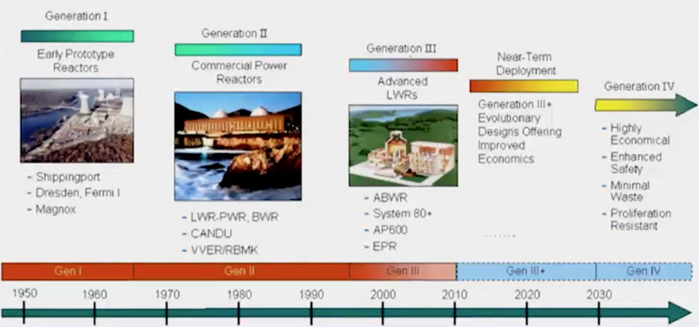

The evolution of different types of nuclear reactors since their inception in the 1950s

*Light Water Reactors (LWR)*

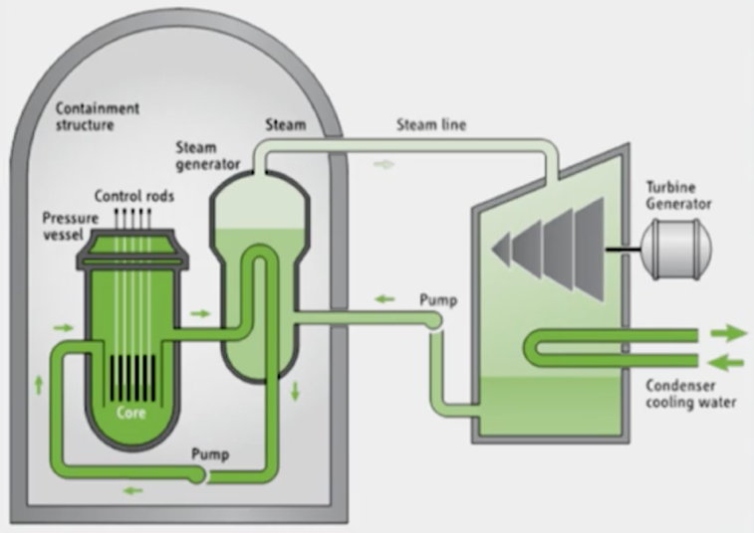Most of the recent third generation reactors are built using what is known as a light water reactor (LWR). LWR concepts use high pressure water to immerse the reactor, and follow the below cycle:

Cycle of water as a coolant in LWR designs

1. The water immersed in the reactor gets hot from the release of heat from the nuclear reactions
2. The heated water gets pumped into a secondary chamber of (cooler) water, producing steam
3. The steam runs the turbine that cools another water source outside of the reactor
4. The cooler water supplies the input water in the reactor

Below are some more characteristics of the LWR:

* The water not only acts as a coolant, but also as a “maintainer” which controls the rate of the reactions
* Most of the fissile material used in the reactor is uranium or mixed oxide fuels. Mixed oxide fuels are manufactured from plutonium either 1) recovered from used reactor fuel that is mixed with uranium, or 2) weapons-grade plutonium
* Most LWR use a so-called “once thru” fuel cycle which means that once the fissile material is exhausted, it gets remoced from the reactor and treated as waste. In some cases -- mostly in France, Scandinavia and Japan – the reactor can close the fuel cycle and use the waste as input to other processes.
* 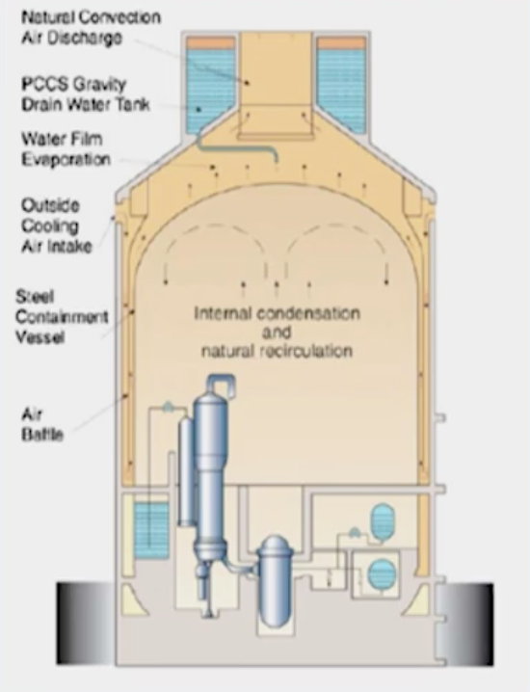These types of reactors have very high energy densities which require a very highly redundant safety mechanism to avoid a (catastrophic) loss of cooling in core

Part of the design of Gen III/LWR use natural convection-driven” cooling in the event there is a loss of coolant. This basically means that the reactor is housed in a larger space to allow for natural recirculation, dispersing the heat to keep temperatures below the maximum allowable.

This design allows for more time to address potential meltdowns. In the case of Fukushima, it was only a matter of hours in which people had to respond to the meltdown. The convection-based design would have allowed a matter of days or weeks to address the issue.

LWR design concepts to allow for natural convection of heat

*Issues with Nuclear*

* Economics

One of the key issues with nuclear is economics – while the total levelized costs of nuclear is competitive with fossil and renewable sources over the lifetime of the plant, the initial capital costs are much higher (~$80/MwH, roughly 6x conventional natural gas) compared to other sources. This initial startup cost gets counteracted by lower variable costs when the nuclear plant is in production.

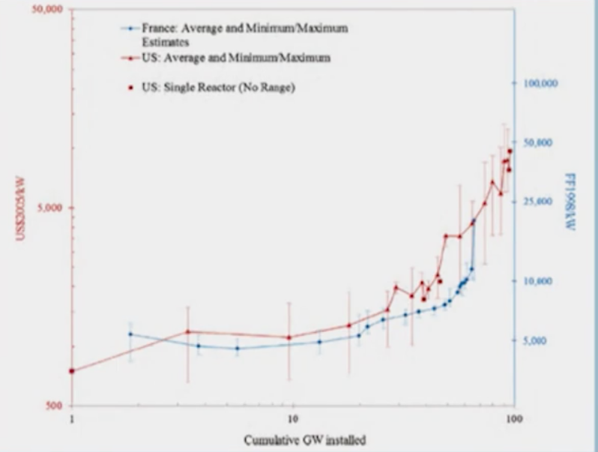Additionally, contrary to what you would expect, the cost of producing nuclear energy plants is *increasing* as more plants come online.

The main reason for this increase in costs is the additional regulatory requirements on the design and operation of nuclear plants, sometimes applied retroactively. There were also delays associated with the creation of plants in France and the US which increased the capital costs.

It should be noted that the costs of power plants in Asia is lower than it is in the West, so monitoring whether or not that trend continues is worthwhile.

Capital costs of nuclear power plants are increasing as more get produce, at least in France and the US

* Spent fuel handling and proliferation

As the waste fuel is taken out of the reactor (after about two years of usage), it needs to be stored somewhere. Most reactors in the US store it in *dry cask storage* but other countries (France, Scandinavia, Japan) have chosen to close the fuel cycle to be able to recycle and reuse the spent fuel.

In the future, there are developments to keep spent fuels in geologic formations. An imperative when figuring out where to store that long-term waste is that there is consent in the communities where there are plans to store the waste.

|  |  |
| --- | --- |
| **Years of lives lost per TwH** | **Example** |
| Wind | 2.7 |
| Nuclear | 25 |
| Gas | 42 |
| Photovoltaics | 58 |
| Coal | 305 |
| Oil | 359 |

* Perception of risk to safety

In the wake of events like Fukushima, there is an understandable perception that nuclear isn’t safe. However, looking at the data, nuclear tends to be one of the safer sources of energy when looking at the number of lives lost in the production of energy from other sources.

*How nuclear energy fits into the global energy mix*

With demand expected to grow over the next few decades, the growth of renewables alone won’t be able to meet the additional demand for energy. Here is [one report](http://www.interacademies.org/33348/Lighting-the-Way-Toward-a-Sustainable-Energy-Future) looking at the international level, but there were many others which back up its findings. Basically, it concluded that nuclear energy has a role to play, even though the main obstacles listed below need to be overcome:

* Replace LWRs with passively safe systems
* Safely decommission older plants
* Implement interim dry-cask waste storage while developing long-term geologic disposal
* Resolve weapons proliferation concerns via technical and international oversight mechanisms

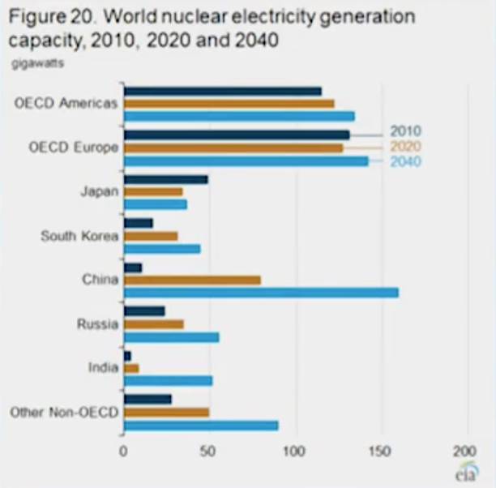*What’s next for nuclear energy?*

Over the next few decades, it is expected that nuclear will power 200-300 GW *additional* power (each plant produces +/- 1 GW), totaling 15-20% of global demand.

As nuclear progresses, reactors will move from Gen II to Gen IV technologies, which would provide some of the benefits. There are research projects around the world implementing some of these technologies:

* Improved economics through innovative reactor design which makes it impossible for a reactor to have a meltdown
* Smaller unit sizes permitting factory construction
* Reductions in long-lived waste production using *fast neutrons* which reduce the radiotoxicity of waste as well as its lifetime

All of the above relates to *fission* technologies, but there is an emerging field of *fusion* energy which combine two or more nuclei together (as opposed to breaking them apart as in fission), mimicking how the Sun produces energy. Although this technology is not ready for large scale production, a few of its benefits include:

* No possibility of core meltdown
* Worst-case accident does not require evacuation at site-boundary
* Eliminations of long-lived radioactive wastes; lifespan of radioactivity would be tens to hundreds of years instead of millennia as it is with fission technology

The developed world has collaborated to create [ITER](https://www.iter.org/), which is essentially a physics experiment to demonstrate the scientific feasibility of fusion energy production; if the ITER experiment is successful, there are other experiments (currently being designed) which are looking at the commercialization of these technologies. The biggest question around nuclear technology (and especially fusion) is whether or not the technologies will be cost competitive with other options available in the market.